THE

Federated Church
OF SYCAMORE

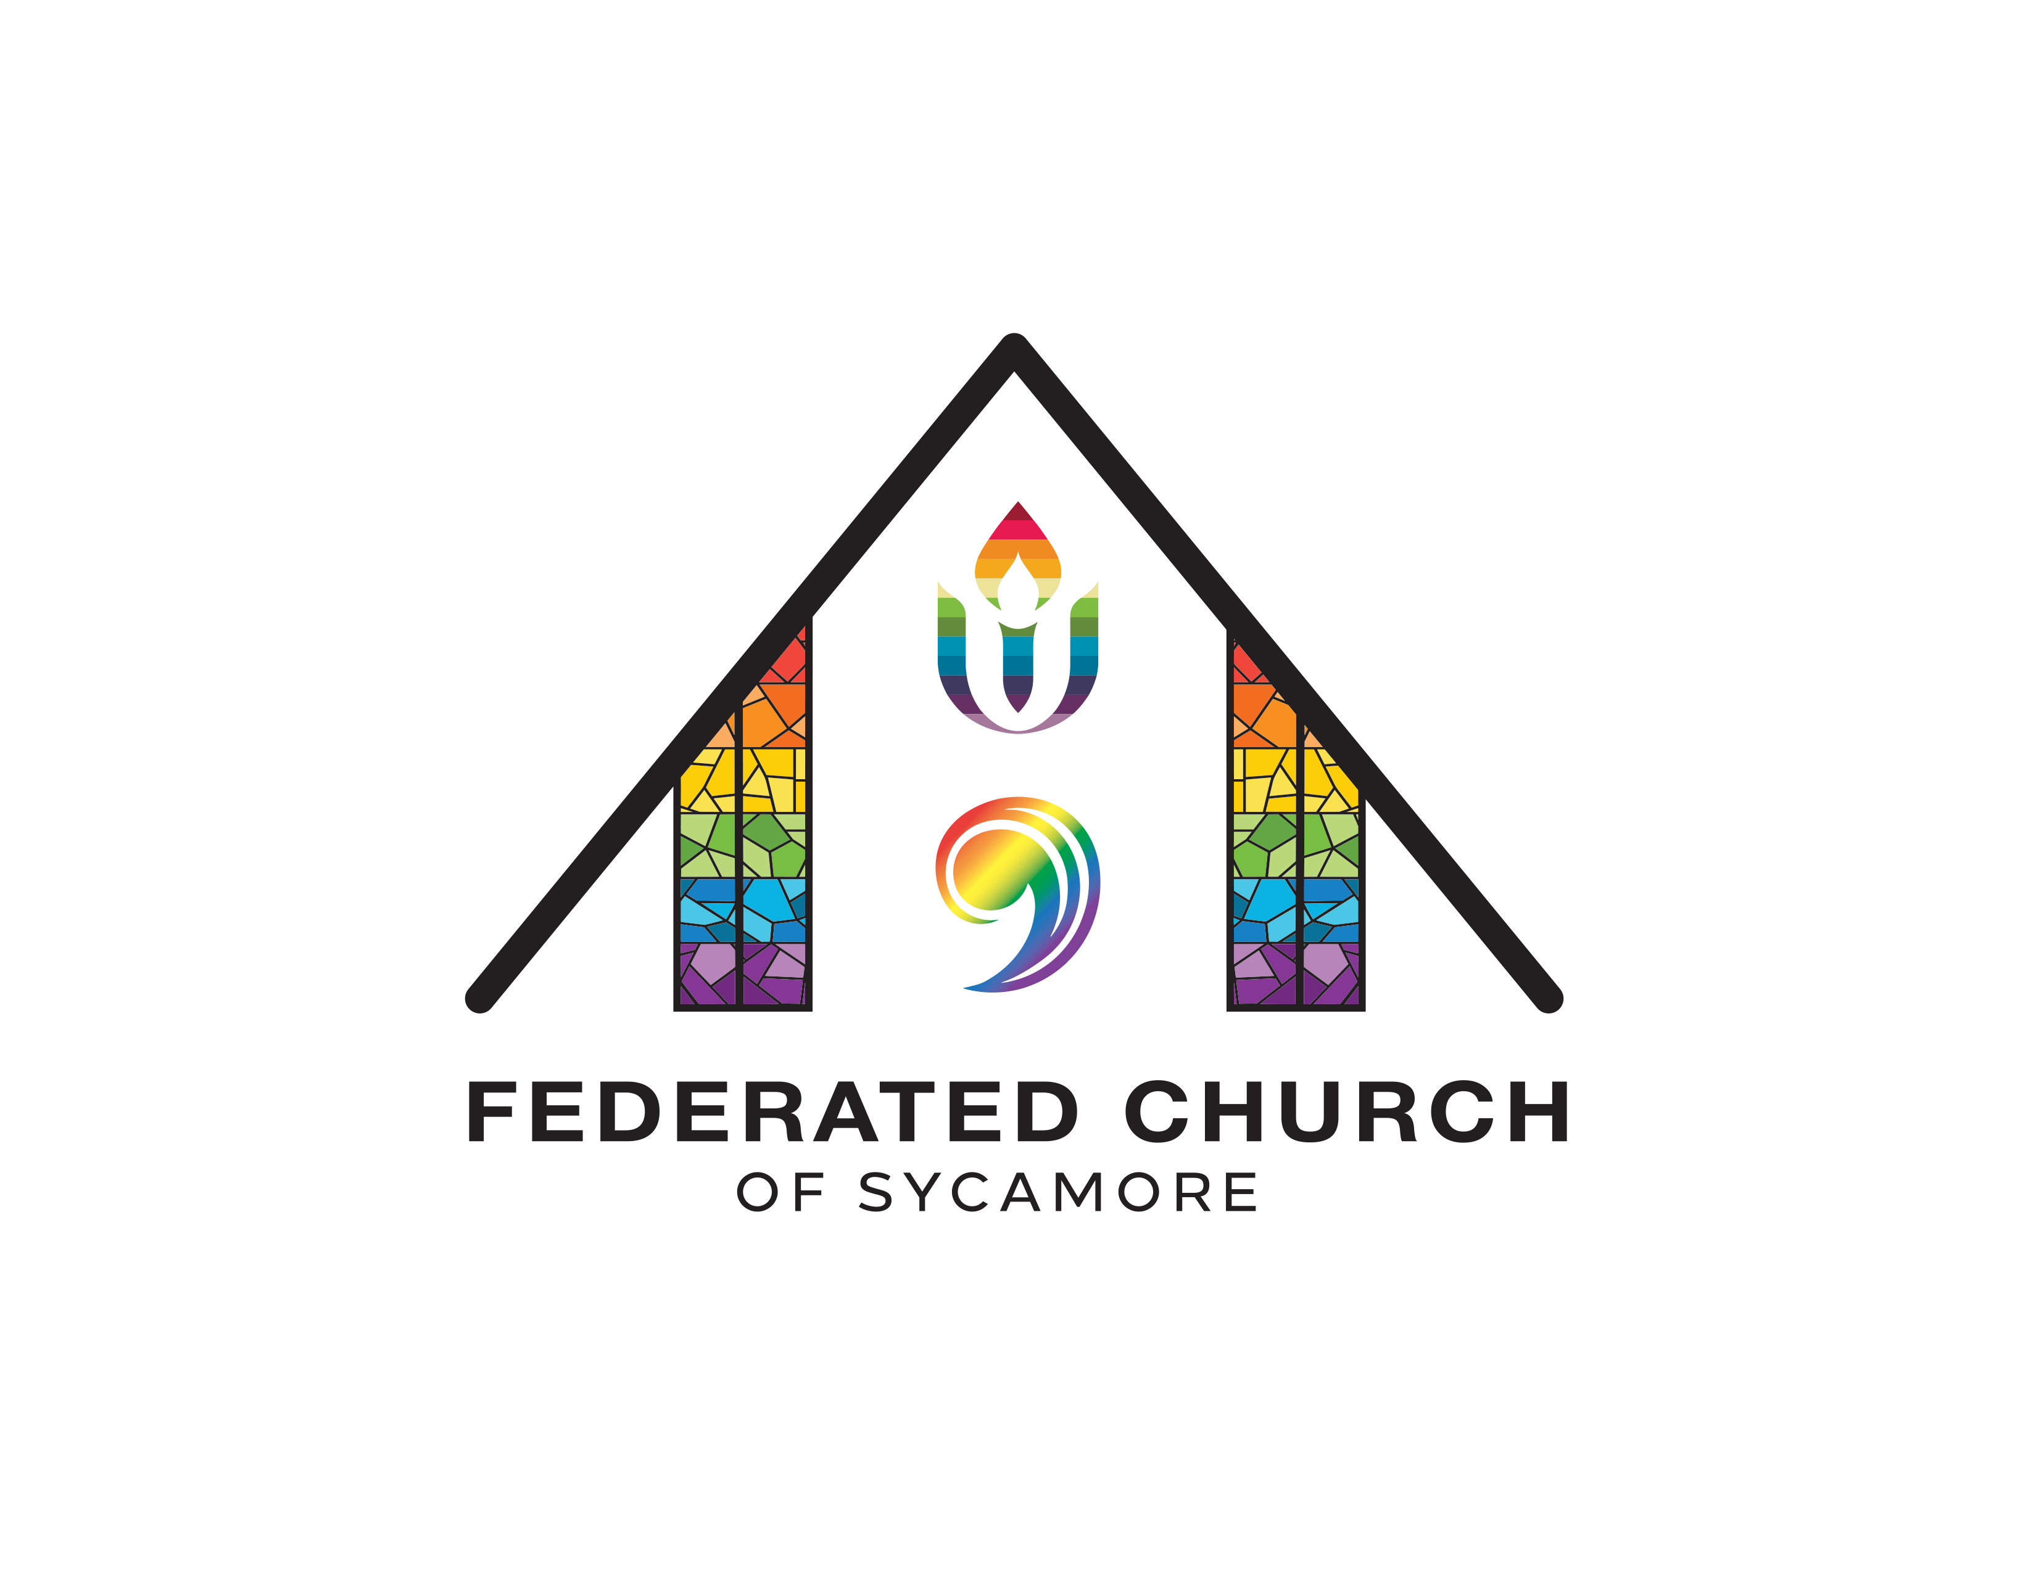

A Congregation of the
United Church of Christ &
Unitarian Universalist Association

YOU ARE WELCOME HERE!
A warm WELCOME to those visiting or
checking out Federated Church!
We’re glad you’re here! Are you looking for more information about who we are, what we do, or how to get involved? Would you like to meet with Pastor Eric or get connected to others? Fill out our brief online Connection Form here, and we will be in touch with you soon!
Federated Church is an Open & Affirming Community
In a time of deep division and vitriolic rhetoric around issues of race, ethnicity, gender, and sexuality, and where the dignity of people living with disabilities or mental health issues are often ignored, demonized, or turned into a joke, we promise to:
Welcome all people of every age, gender, race, national origin, faith expression, marital status & family structure, sexual orientation, gender identity or gender expression, physical ability, mental or emotional condition, economic and social status, and educational background to share in the life, leadership, ministry, fellowship, worship, sacraments, responsibilities, blessings, and joys of our church family.
The Rainbow Flag: We proudly display a rainbow flag at the front of our sanctuary as a visual declaration of God’s extravagant and inclusive love, as well as of our own “promise of welcome” to all people. Our prayer is that all can be their truest selves here. This flag serves as a particular signal that our church is a safe and affirming space for LGBTQ persons to be, to belong, to lead, to question, and to grow in faith.

Order of Worship | July 28, 2024, 10:00 am
All music can be found at the back of the bulletin.
Prelude “You Are My All in All” D. Jernigan/arr. M. Hayes
Welcome & Passing the Peace
We invite you to like the video and/or say “Hi!” in the comments to let us know you’re here!
Gathering Song “Gather Us In” vv. 1, 3, 4 (p. 3)
Prayers of the People
Centering Moment
This is your time to center more deeply into the presence of God/Love. We invite you to take a slow, deep breath, read the poem below, and then: ponder the Meditation Question(s); offer a silent prayer; or simply let the music wash over you.

“I wish it need not have happened in my time," said Frodo.
“So do I," said Gandalf, "and so do all who live to see such times. But that is not for them to decide. All we have to decide is what to do with the time that is given us.”

~ J.R.R. Tolkien, The Lord of the Rings
Meditation Question
  - Think of a time you faced something difficult or heartbreaking and cried out: “Why?!” What did you “do with the time given you” that moved you forward in ways that brought healing, growth, connection, and compassion?
Silent Prayer & The Lord’s Prayer
Our Father, who art in heaven, hallowed be thy name. Thy kingdom come, Thy will be done on earth as it is in heaven. Give us this day our daily bread, and forgive us our debts, as we forgive our debtors. And lead us not into temptation, but deliver us from evil. For Thine is the kingdom, and the power, and the glory forever. Amen.
Sung Response “Come to Me, O Weary Traveler” (p. 2)
Scripture Job (excerpts)
Sermon “THE Question”
Musical Meditation
Our Shared Life & Offering
Offering Opportunities
Offertory “What a Friend We Have in Jesus” C.C. Converse/arr. M. Hayes
1
Doxology
Praise God from whom all blessings flow.
Praise God all creatures here below.
Praise God for all that Love has done.
Creator, Christ, and Spirit, One. Amen.
Prayer of Dedication
Sending Hymn “O Love that Will Not Let Me Go” vv. 1-3 (p. 4)
Benediction
Postlude “Shine, Jesus, Shine” Graham Kendrick/arr. M. Hayes
Thank you for joining us for worship!

WORSHIP NOTES
Serving us this morning are:
Pastor: Rev. Eric J. Ogi | Ministers: All of us! | Music Director: Gary Mattin
Children’s Church Coordinator: Janis Schnurr-Trebe | Liturgist: Sheldon Turner
Ushers: Paula von Ende, and Bev & Skip Schramer
Ushers for August 4: Pam Wagener, Chris Borresen, and Skip Schramer
All music this morning is used with permission: CCLI License #3234671

“Come to Me, O Weary Traveler”
Sylvia Dunstan
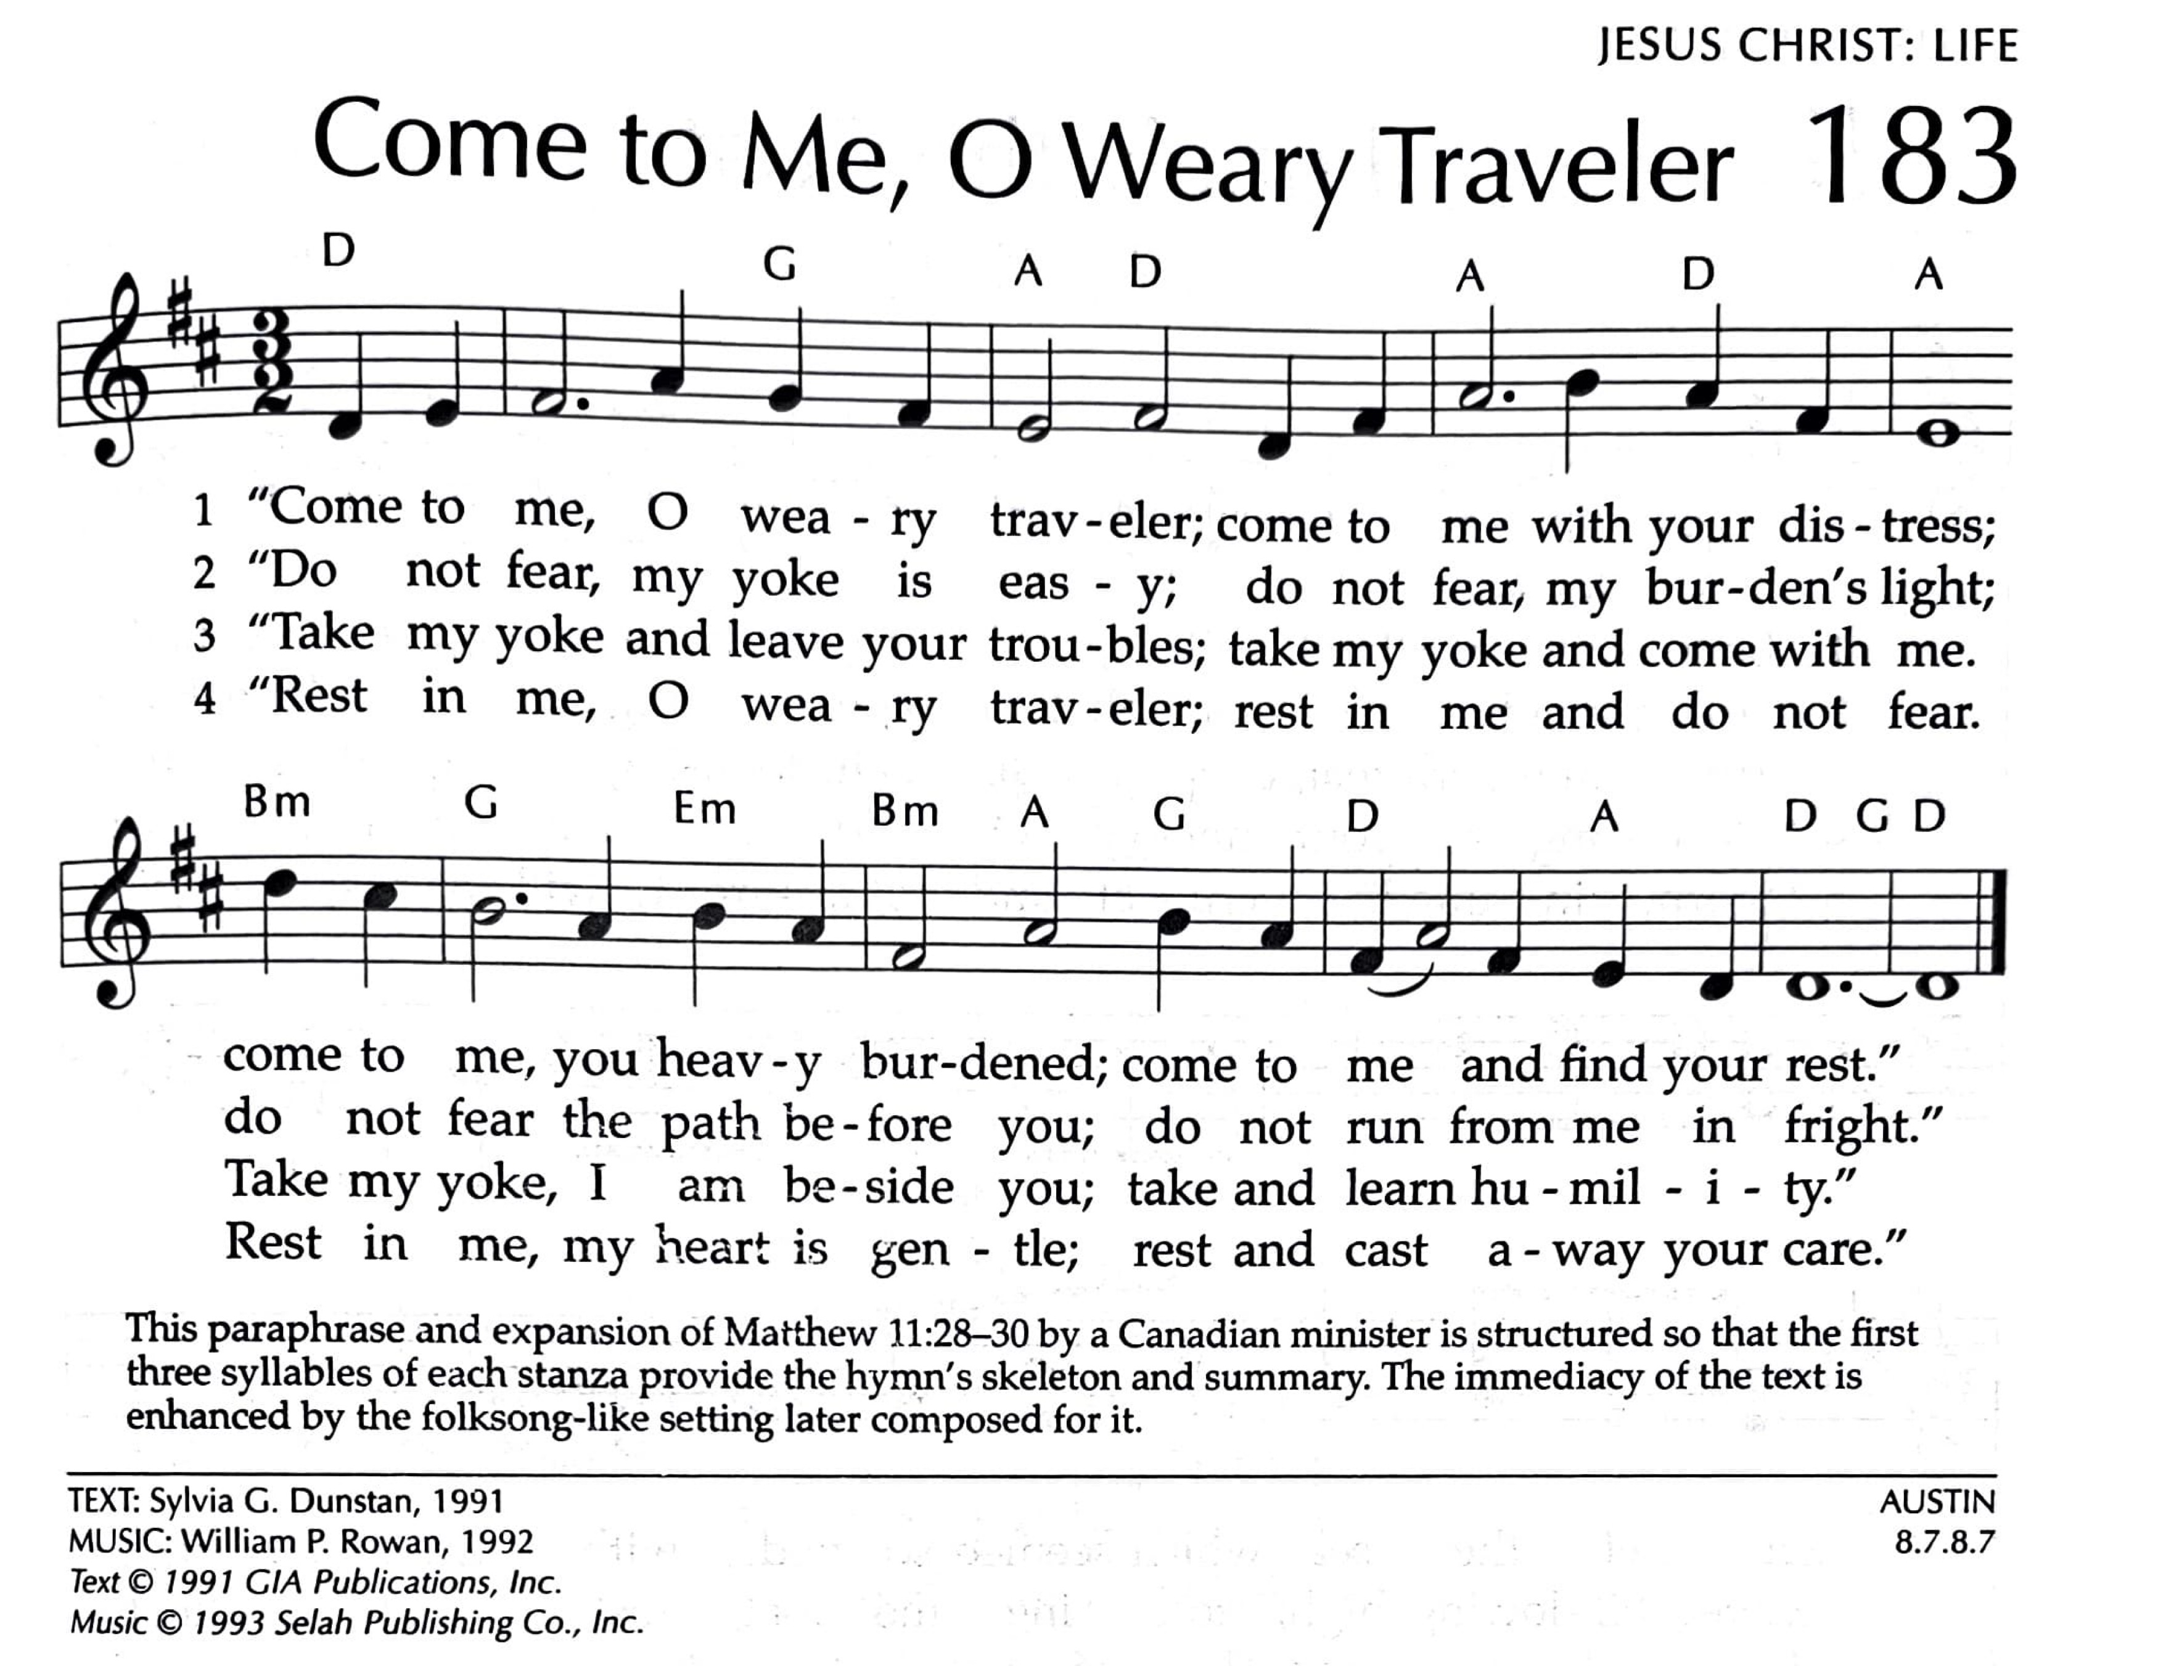

2
“Gather Us In”
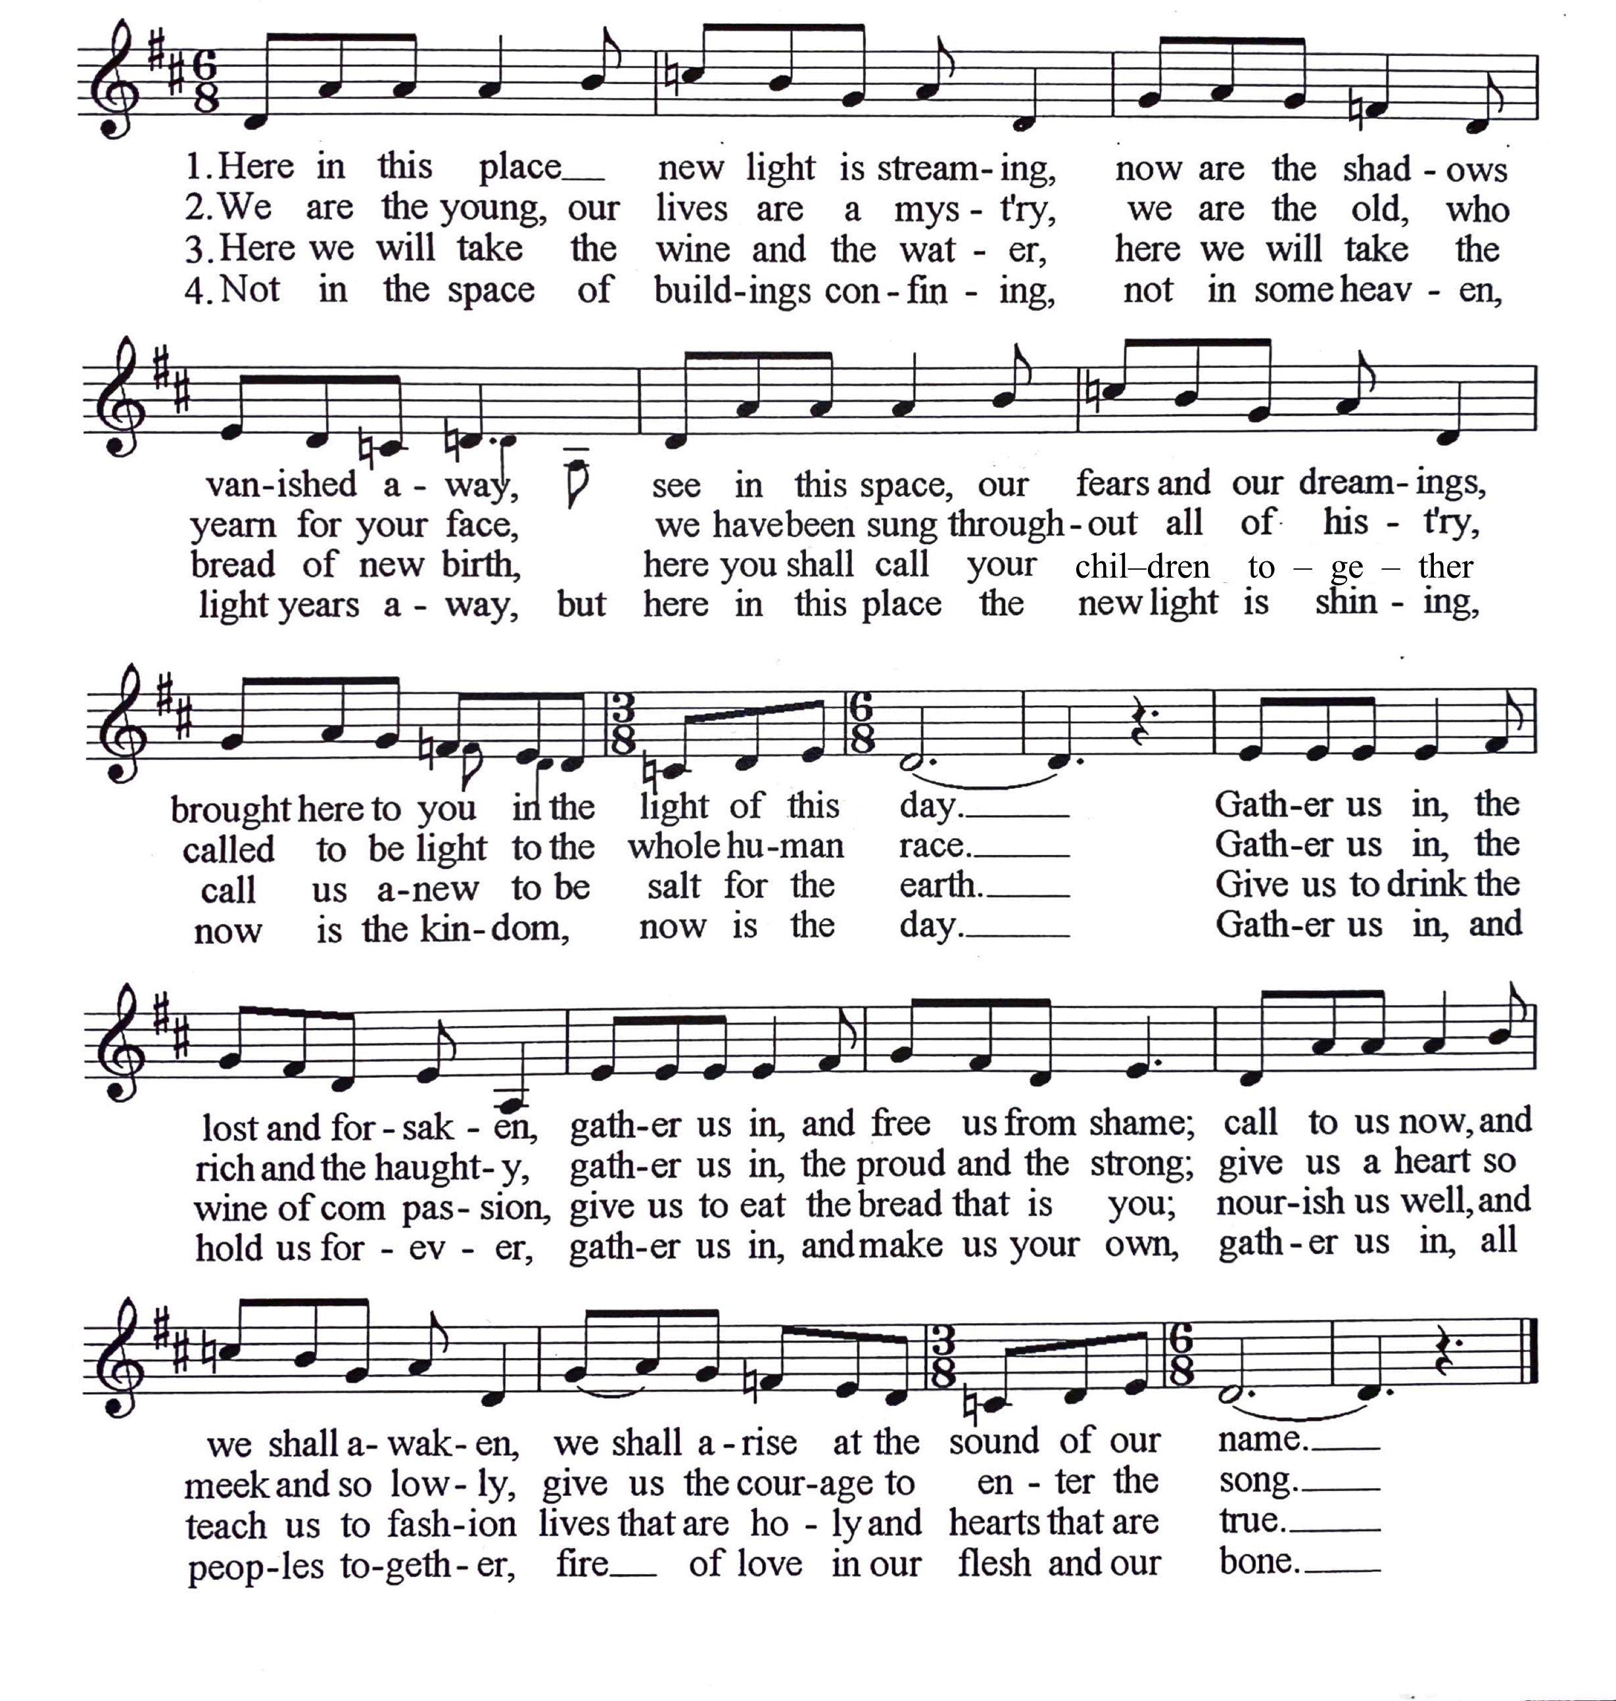
Marty Haugen

3
“O Love That Will Not Let Me Go”
George Matheson
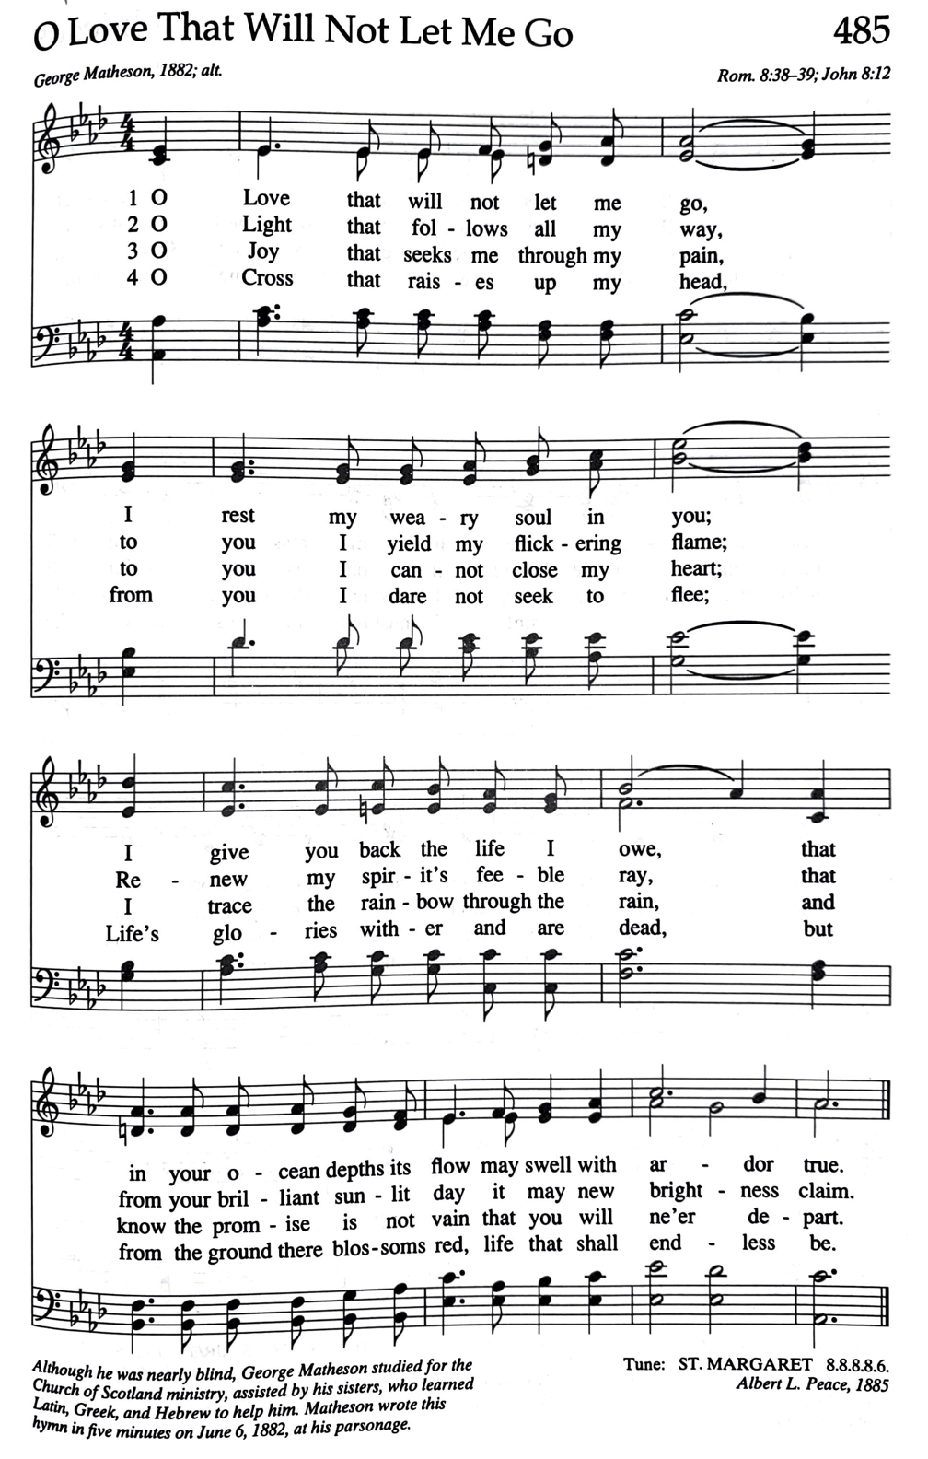

4
ANNOUNCEMENTS
July Love Offering | Federated Preschool
The Federated Preschool is now a half-day and a full-time year-round preschool center. Through community grants and church support, the Preschool has added: previous playground upgrades, a security doorbell to the main entry way, another classroom, new books and toys, kid-sized tables and chairs in Dutton Hall, a large freezer and extra shelving in the kitchen, and air conditioning in the classrooms.
Bids are being sought for our next big project, playground maintenance: adding better drainage (so it’s not a pond when it rains!) and replacing the rubber mulch. Love Offering donations along with community grants will make this project possible (it’ll cost at least several thousand dollars)!
Donations in any amount are welcome and can be placed in the collection plate on Sunday, mailed to the church at The Federated Church, 612 W. State St., Sycamore, IL 60178 (be sure to write “Federated Preschool” on the memo line), or given online at https://bit.ly/GiveFCS.
Filling and Blessing of the Backpacks
Set-up: Sat., 8/3, 6:30PM, Packing: Sun., 8/4, following worship
We are filling 100-120 backpacks for students in Hope Haven, Safe Passage, Mason Court Apartments, and under the care of the Department of Children & Family Services.
There are TWO opportunities to help!
The set-up, on Saturday, August 3, beginning at 6:30 pm (setting up tables, laying out the backpacks and supplies) and the actual packing on Sunday, August 4, following worship.
All ages are welcome, and everything is provided; bring ready hands, rolled-up sleeves, and an eagerness to help!
Conversations Around Values, Vision, and Vitality
Final Gathering: Wed., July 31, 5:30pm, Mayfield Congregational Church
Join us for the final gathering in our July mid-week series hearing different perspectives from local UCC pastors followed by small group breakout conversations as we consider how we can boldly live out our progressive Christian faith in our wider community.
Recycle/Reuse Bulletin Covers
We will recycle and reuse the bulletin covers. Please place the cover in the basket at the back of the sanctuary on your way out. You are welcome to keep the insides. Thanks!

Weekly eNews
Scan or click this QR code with your phone camera to see the most recent
eNews with all these announcements and more! Subscribe tab is at the top.

5
OUR FEDERATED VALUES
We believe in God
At the center of our faith is the surprising, unsettling, and deeply personal God found in the Bible, most profoundly revealed in the life, teachings, death, and resurrection of Jesus. At Federated, our primary interest is not merely talking about God, but in encountering the Mysterious Force at the heart of the universe. This is a God who comforts us where we need to be comforted and challenges us where we've become complacent. This is a God who will not be confined to dogmatic teachings, nor even to the Bible. We believe that we are invited to encounter this God everywhere: in nature, science, one another, and in other religious traditions as well.
Each person is on a unique spiritual journey
We value faith as a journey rather than a destination. We recognize that each person is at a different place on their journey, so we focus on “testimonies” of faith rather than “tests” of faith; stories of how we are being transformed, rather than dogmas we must affirm. Here, you are welcome to belong, question, explore, and lead whether you grew up in church and loved it, or you've had a painful relationship with Christianity; you are welcome whether you feel your faith is unshakeable or you're not sure if you believe in God at all. You are welcome to join a community of people "on the way": encouraging and caring for one another, learning and growing together, and serving alongside each other as we build, in some small way, the world we believe God dreams of.
Building authentic community across our differences
We are an "Open and Affirming" congregation, which is our way of saying that we value diversity. In a time of deep division, we believe it is paramount to gather people from a variety of backgrounds, experiences, and identities in order to build authentic relationships and community. We believe that the simple but courageous work of showing up and being together in this way is one necessary element in healing our nation and world's deep divisions.
We believe in peace through justice
In this congregation, conversations regarding racism, sexism, poverty, war, immigration, homophobia, hunger, abuse, and a host of other issues are commonplace, both from the pulpit and around the table. We know that the Realm of God is not being experienced on earth so long as people are being hurt. With Martin Luther King Jr., we believe that we are all "caught in an inescapable network of mutuality, tied in a single garment of destiny," and that "none of us can be free until all are free." Which means that, as a community, we have a God-given responsibility and mission to work for justice and healing in our neighborhood and beyond. Jesus says: “I have come that they may have life and have it abundantly” (John 10:10). This work is defined not merely by what we are against, but the vision we are for—flourishing for all!

“Welcoming Any, Loving All”

The Federated Church is affiliated with two national denominations:
the United Church of Christ & the Unitarian Universalist Association



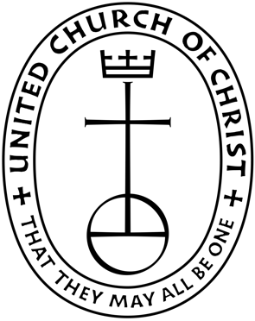



Follow us on
Facebook & Instagram:
@FederatedChurchSycamore

www.fedsycamore.org

Church Office Phone: (815) 895-2706 || Email: Office@fedsycamore.org
Pastor Eric Cell: (815) 797-2250 || Email RevEric@fedsycamore.org
Federated Church Preschool, Director Bobbi Clough
Phone: (815) 764-9473 || Email: Preschool@fedsycamore.org
Address: 612 W. State Street, Sycamore, IL 60178
12

