THE

Federated Church
OF SYCAMORE

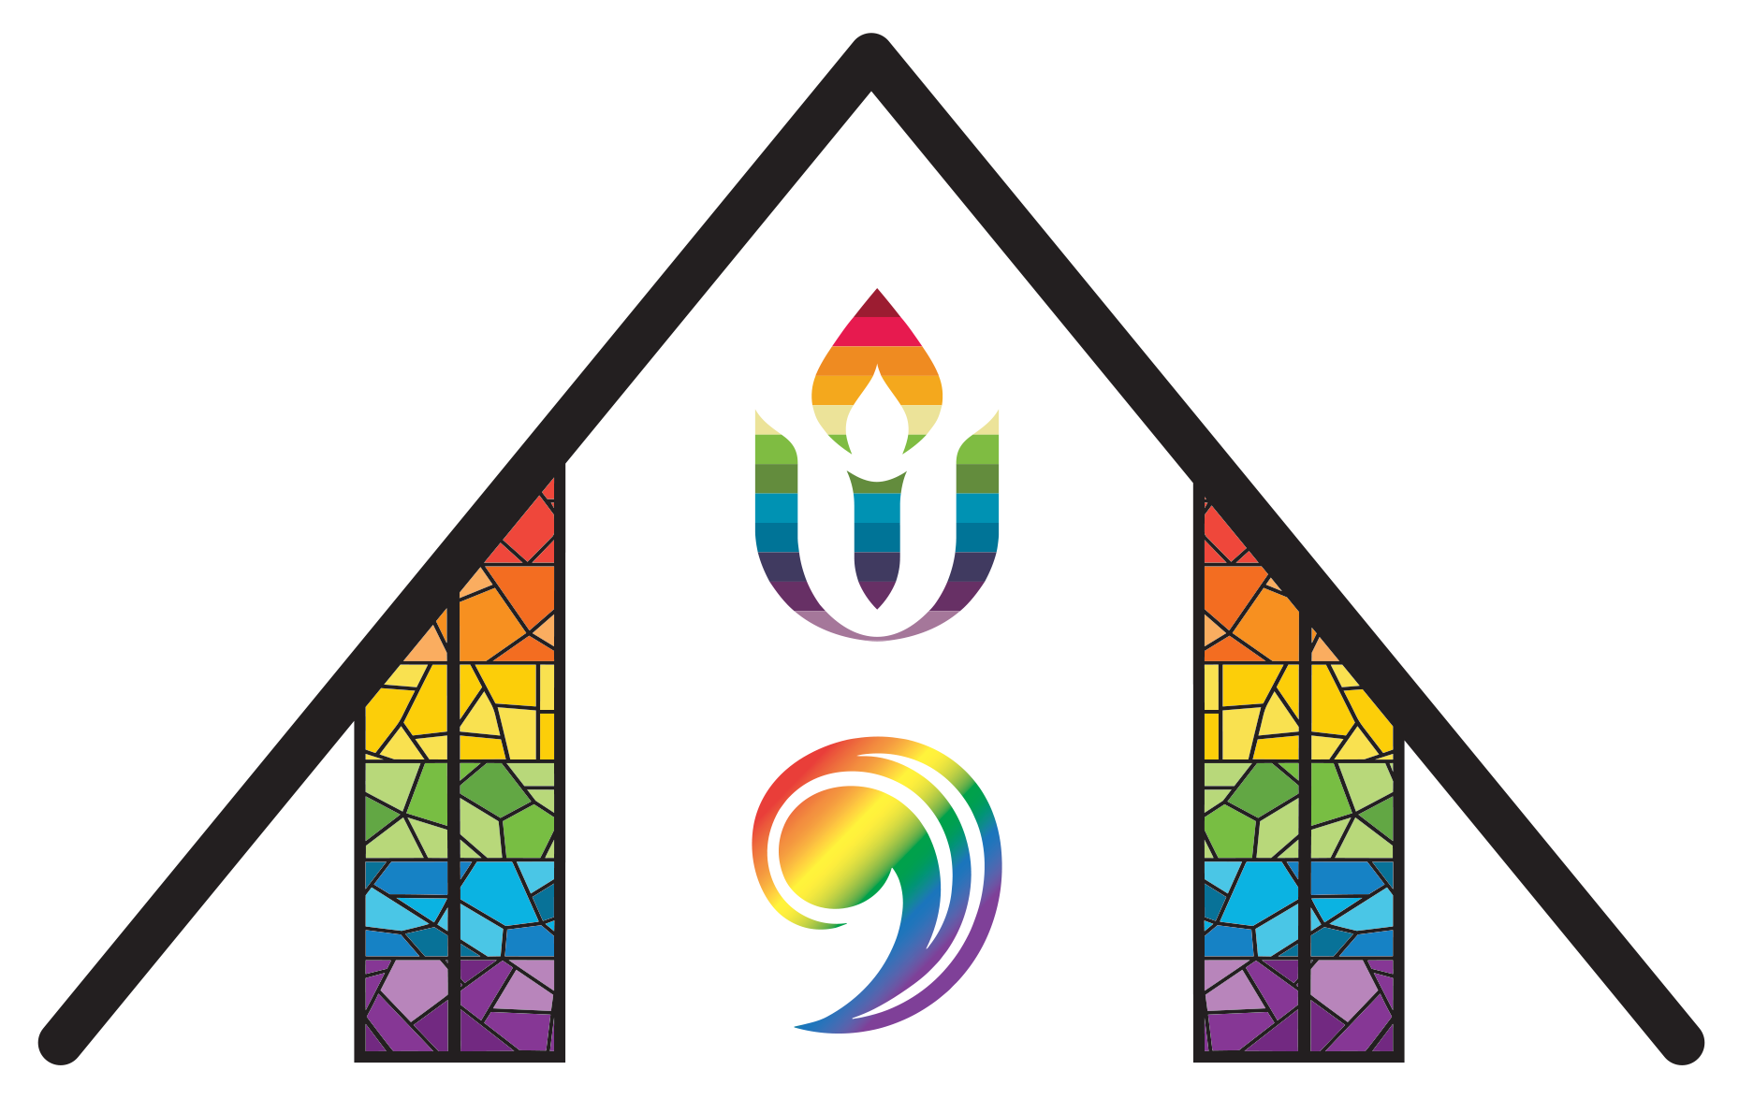

A Congregation of the
United Church of Christ &
Unitarian Universalist Association

YOU ARE WELCOME HERE!
A warm WELCOME to those visiting or
checking out Federated Church!
We’re glad you’re here! Are you looking for more information about who we are, what we do, or how to get involved? Fill out our brief online Connection Form here, and we will be in touch with you soon!
Federated Church is an Open & Affirming Community
In these times of deep division, vitriolic rhetoric, and violence against people over issues of race, ethnicity, gender, sexuality, immigration status, disability, and mental health, Federated Church has formally adopted two covenants guiding our life together:
We welcome all people of every age, gender, race, national origin, faith expression, marital status & family structure, sexual orientation, gender identity or gender expression, physical ability, mental or emotional condition, economic and social status, and educational background to share in the life, leadership, ministry, fellowship, worship, sacraments, responsibilities, blessings, and joys of our church family.
We commit to protecting our migrant neighbors through acts of sanctuary, solidarity, and justice. We will not stand by in the face of unjust enforcement. We will act, love, and speak as our faith commands—with courage and compassion.
The Rainbow Flag: We proudly display a rainbow flag at the front of our sanctuary as a visual declaration of God’s extravagant and inclusive love, as well as of our own “promise of welcome” to all people. Our prayer is that all can be their truest selves here. This flag serves as a particular signal that our church is a safe and affirming space for LGBTQ persons to be, to belong, to lead, to question, and to grow in faith.

Order of Worship | May 24, 2026, 10:00 am
All music can be found at the back of the bulletin. Please join in reading those parts printed in bold.
Prelude “You Are My All in All” Dennis Jernigan/arr. Mark Hayes
Welcome
Call to Worship (Psalm 47 read responsively)
Leader: Clap your hands, all you peoples;
shout to God with loud songs of joy.
People: For the Lord, the Most High, is awesome,
a great king over all the earth.
Leader: He subdued peoples under us
and nations under our feet.
People: He chose our heritage for us,
the pride of Jacob whom he loves.
Leader: God has gone up with a shout,
the Lord with the sound of a trumpet.
People: Sing praises to God, sing praises;
sing praises to our King, sing praises.
Leader: For God is the king of all the earth;
sing praises with a psalm.
People: God is king over the nations;
God sits on his holy throne.
Leader: The princes of the peoples gather
as the people of the God of Abraham.
For the shields of the earth belong to God;
he is highly exalted.

Passing the Peace
We invite you to like the video and/or say “Hi!” in the comments to let us know you’re here.
Gathering Hymn “Send Us Your Spirit” (p.3)
Prayers of the People
Sharing Prayers of Joy & for Healing
1
Pastoral Prayer & The Lord’s Prayer
Our Father/Mother/Creator who is in heaven, hallowed be your name.
Your kin(g)dom come, your will be done, on earth as it is in heaven. Give us this day our daily bread, and forgive us our debts, as we forgive our debtors. Lead us not into temptation, but deliver us from evil. For yours is the kingdom, the power, and the glory forever. Amen.
Sung Response “Spirit of the Living God” 2x (p.4)
Scripture Acts 2:1-13
Sermon
Sung Response “Breathe on Me, Breath of God” (p.5)
Our Shared Life & Offering
Offering Opportunities
Offertory
Doxology
Praise God from whom all blessings flow.
Praise God all creatures here below.
Praise God for all that Love has done.
Creator, Christ, and Spirit, One. Amen.
Prayer of Dedication
Sending Song “Spirit, Spirit of Gentleness” vv. 1, 3, 4 (p.6)
Benediction
Postlude “How Excellent Is Thy Name” Dick Tunney/arr. M. Hayes
Thank you for joining us for worship today!

2
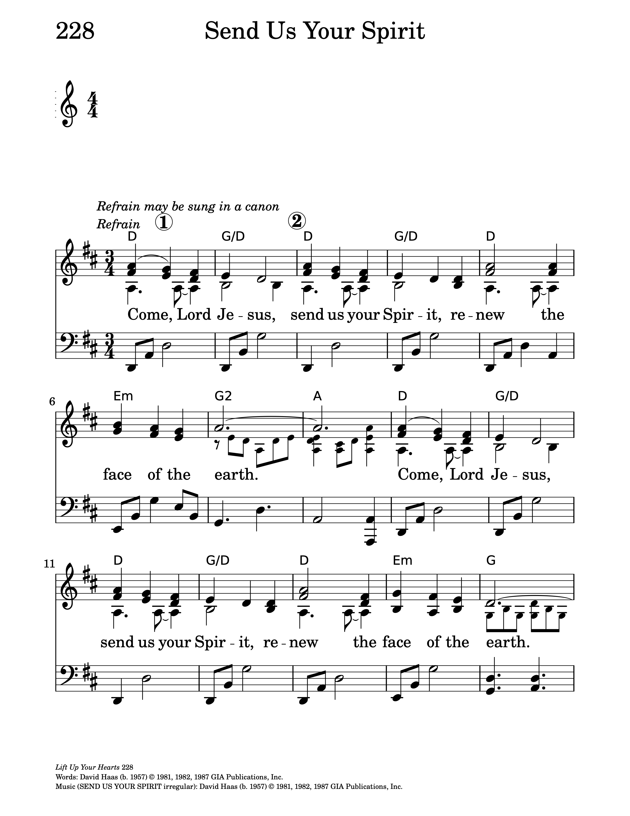
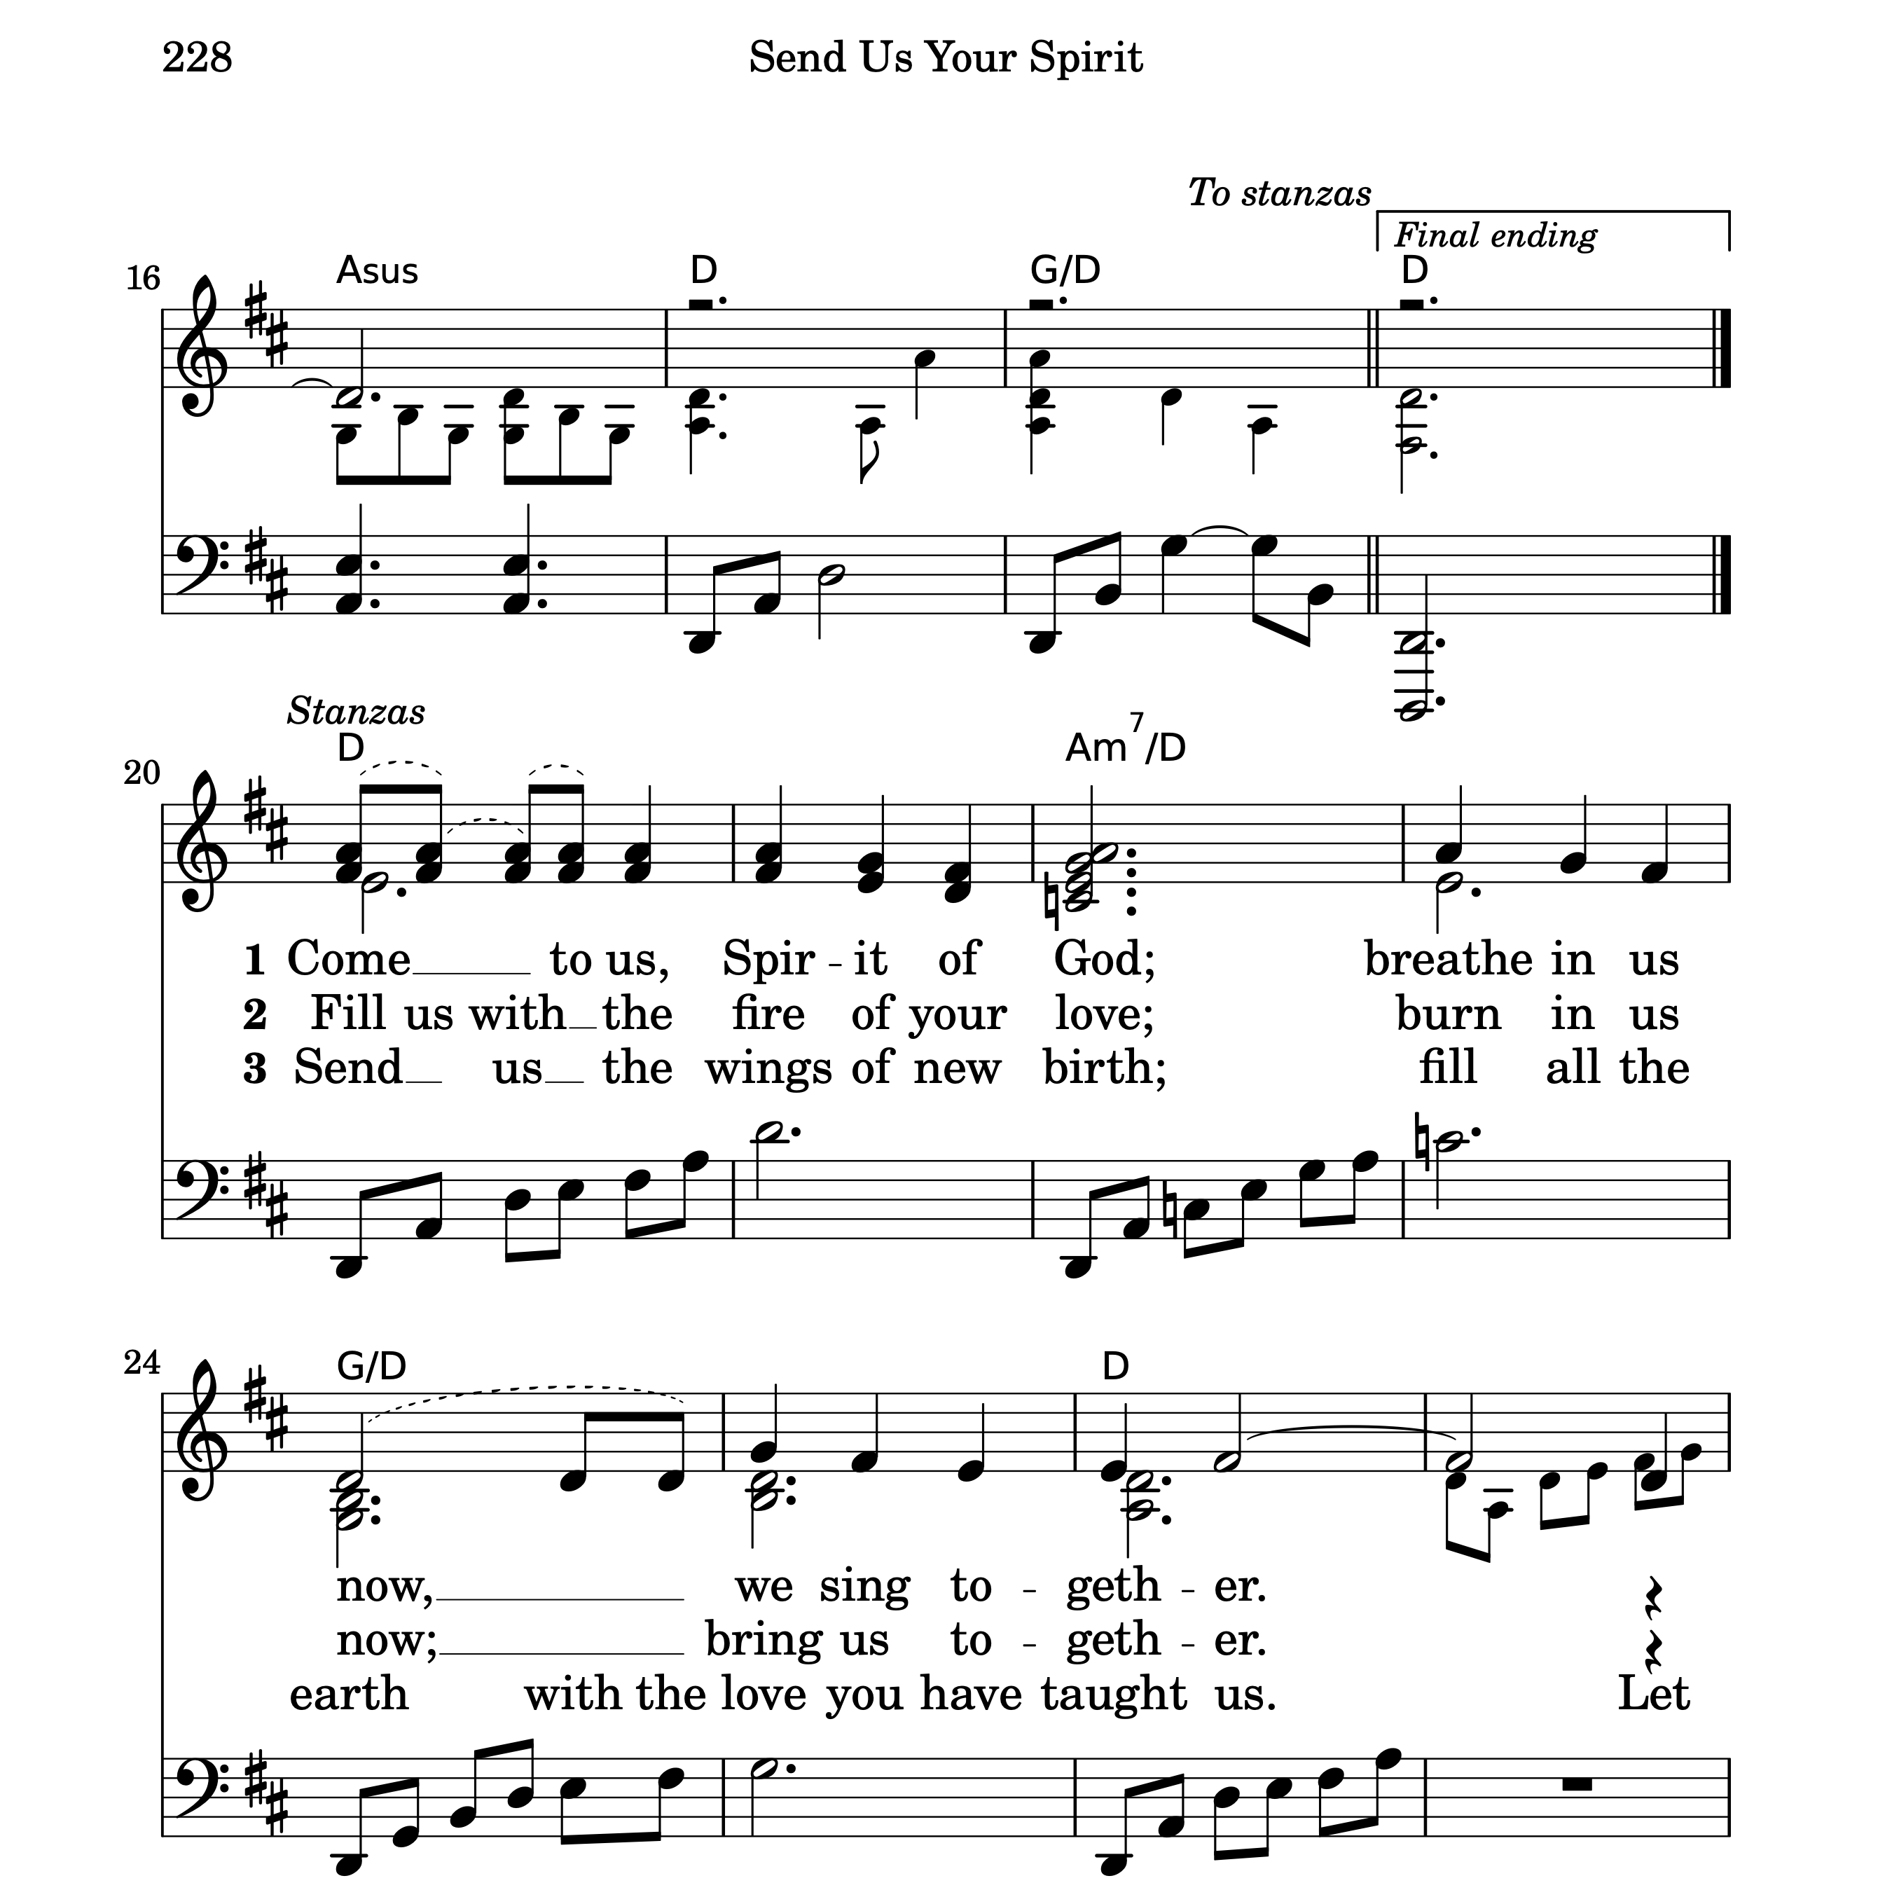
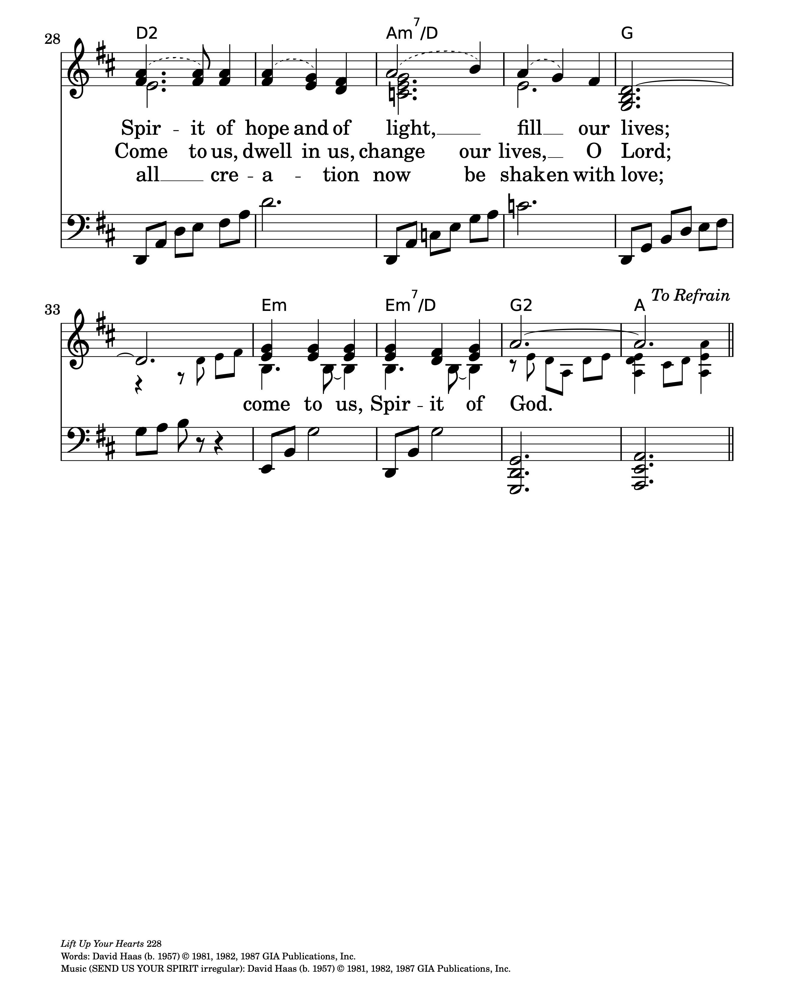
“Send Us Your Spirit” by David Haas

3
“Spirit of the Living God” by Daniel Iverson
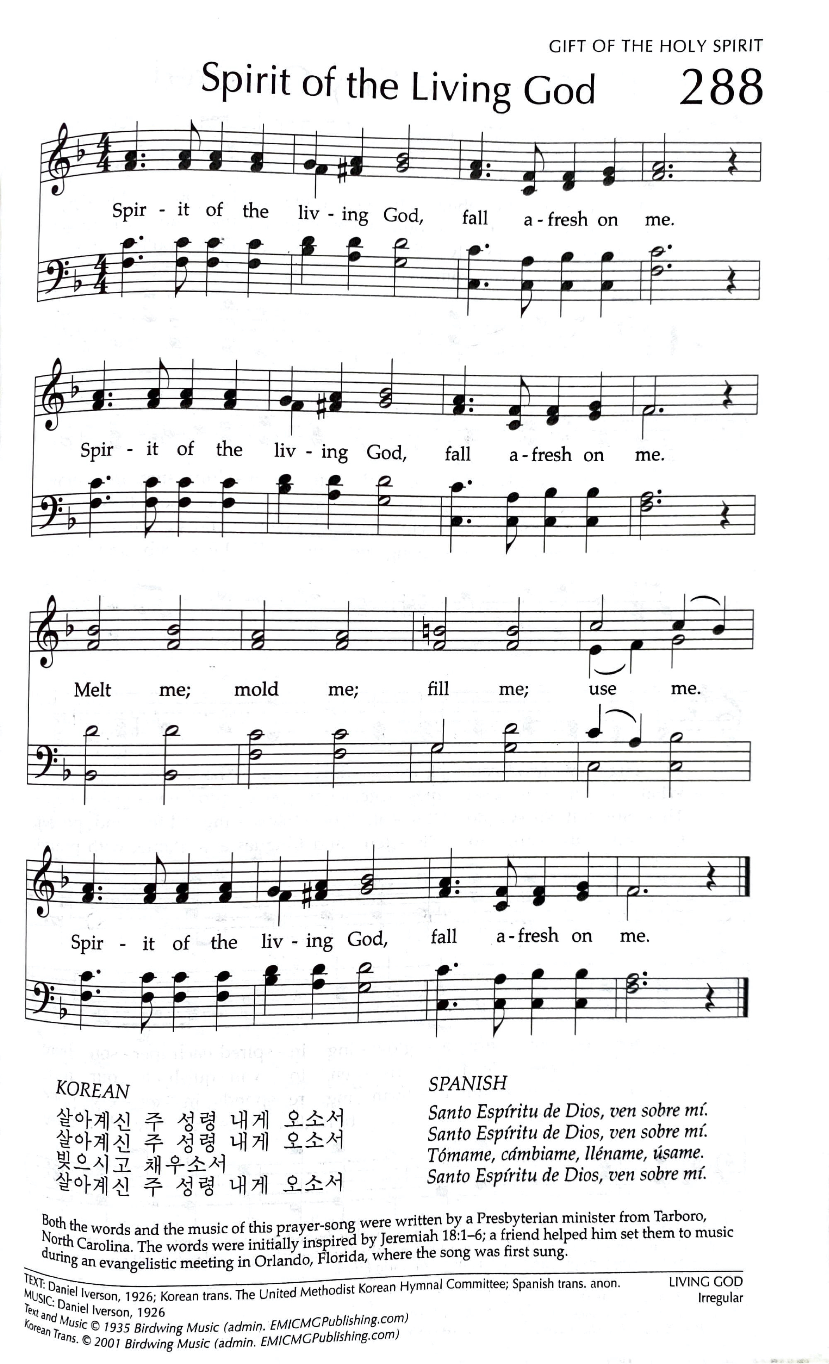

The languages below reflect the diversity within our own wider church community
TAGALOG
Espiritung Banal ng Dios, Puspusin ako
Sa madling kasalanan, Linisin Mo.
Hubugin, At gawing bago
Espiritung Banal ng Dios, Puspusin Mo.

4
“Breathe on Me, Breath of God” by Edwin Hatch

5
“Spirit, Spirit of Gentleness” by James K. Manley
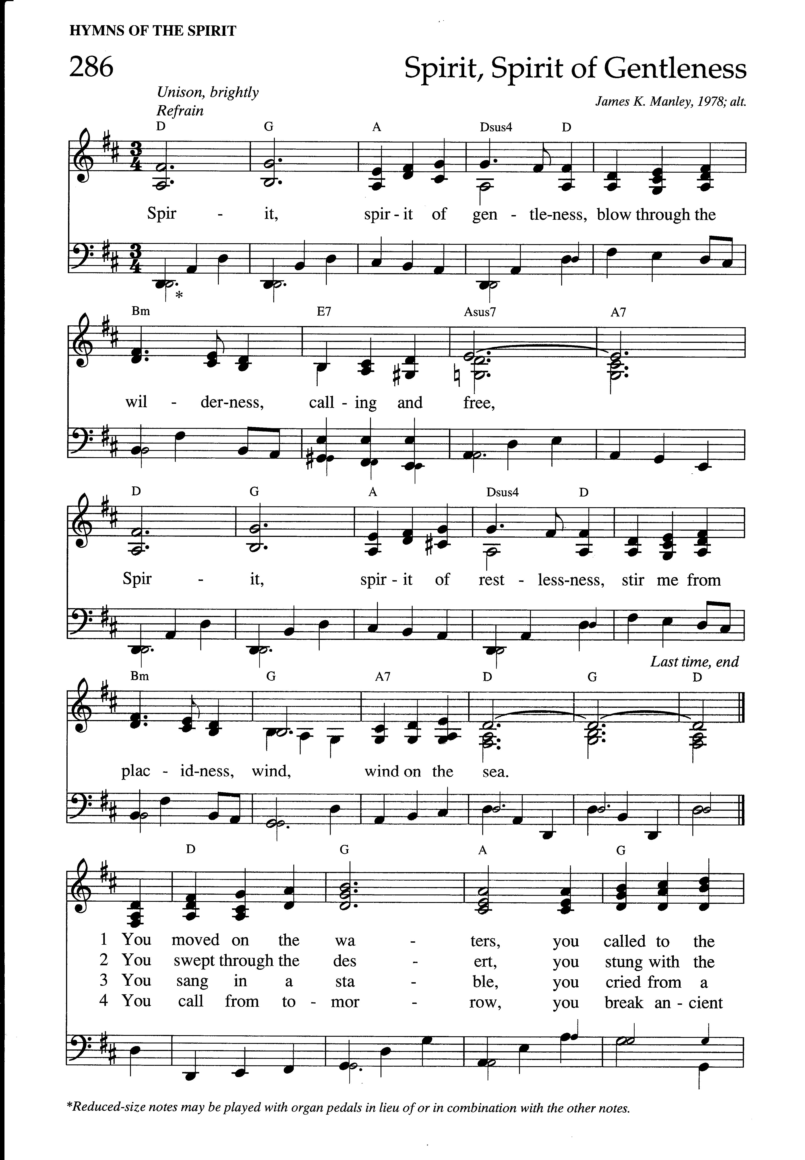
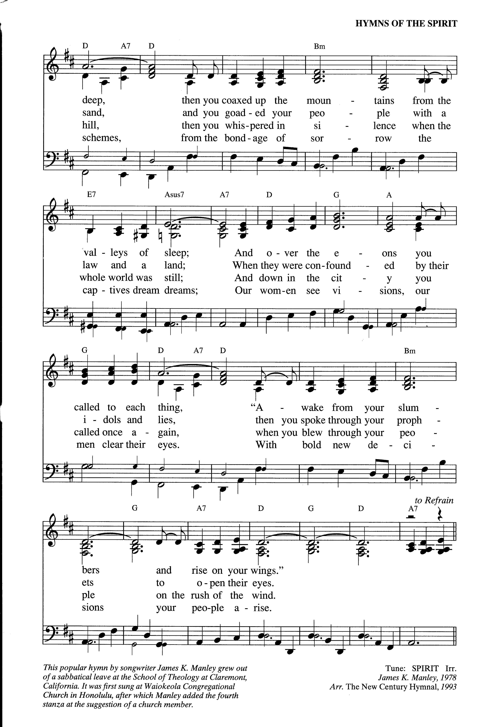

6
WORSHIP NOTES
Serving us this morning:
While Pastor Eric is away on Parental Leave, we are grateful to be led in worship this morning by Pastor Alex Wilson (he/him). Next Sunday, we are excited to welcome
Rev. Muriel Morley Jahn (she/they).
Pastor: Rev. Eric J. Ogi | Ministers: All of us! | Music Director: Gary Mattin
Children’s Church Director: Bill O’Hagan | Children’s Ministry Support: Khat Hetland Liturgist: Phil Wagener | Ushers: Paula von Ende, and Bev & Skip Schramer
Ushers for Sunday, May 31: Alice Whitney, and Bev & Skip Schramer
All music is used with permission: CCLI Copyright: #3234671; CCLI Streaming: #22467093
CONGREGATIONAL NOTES
Church Leadership for August 2025 – August 2026:
Moderator: Gip Seaver | Associate Moderator: Bill O’Hagan | Past Moderator: Chris Borresen | Should you have any questions concerning the church, how to get involved, or who to contact about something, please reach out to one of them or Pastor Eric, and they will get you the information you need or connect you to someone who can.
PASTOR ERIC’S PARENTAL LEAVE
Through Sunday, July 19
Important information while Pastor Eric is away on parental leave.
Congregational Care
During Pastor Eric’s Parental Leave, if there is a specific prayer request or concern, please reach out to one of the leaders of our Caring Ministry: Suzanne Juday (Suzanne.Juday@idealindustries.com), Karen Hamingson (khamingson@gmail.com), Linda Babcock (lindambabcock@gmail.com), Pam Kitterman (hospicesis@comcast.net), Deb Paulin (DJPaulin826@gmail.com), and Malorie Nelson (malnel606@hotmail.com). They will do their best to connect people to a support person and make sure every care need gets met.
In case of Pastoral Emergency, once you reach out to a member of the Caring Ministry, they will be in touch with Pastor Eric directly. If Pastor Eric is unable to meet emergency needs during his leave, Pastor John Dorhauer of First Congregational UCC in DeKalb will be available. Pastor John also provided emergency spiritual care coverage for Pastor Eric last summer during his sabbatical.
Church Leadership
Our Moderator Team: Gip Seaver, Moderator, (gipseaver@gmail.com); Chris Borresen, Past Moderator, (cboressen@gmail.com); and Bill O'Hagan, Assoc. Moderator, (misterohagan@gmail.com), along with the Leadership Board will continue providing leadership during Pastor Eric's leave. Please reach out to one of them if you have any
questions or concerns related to the ministries and happenings of the church. If they are unable to answer your question, they will point you in the right direction!

7
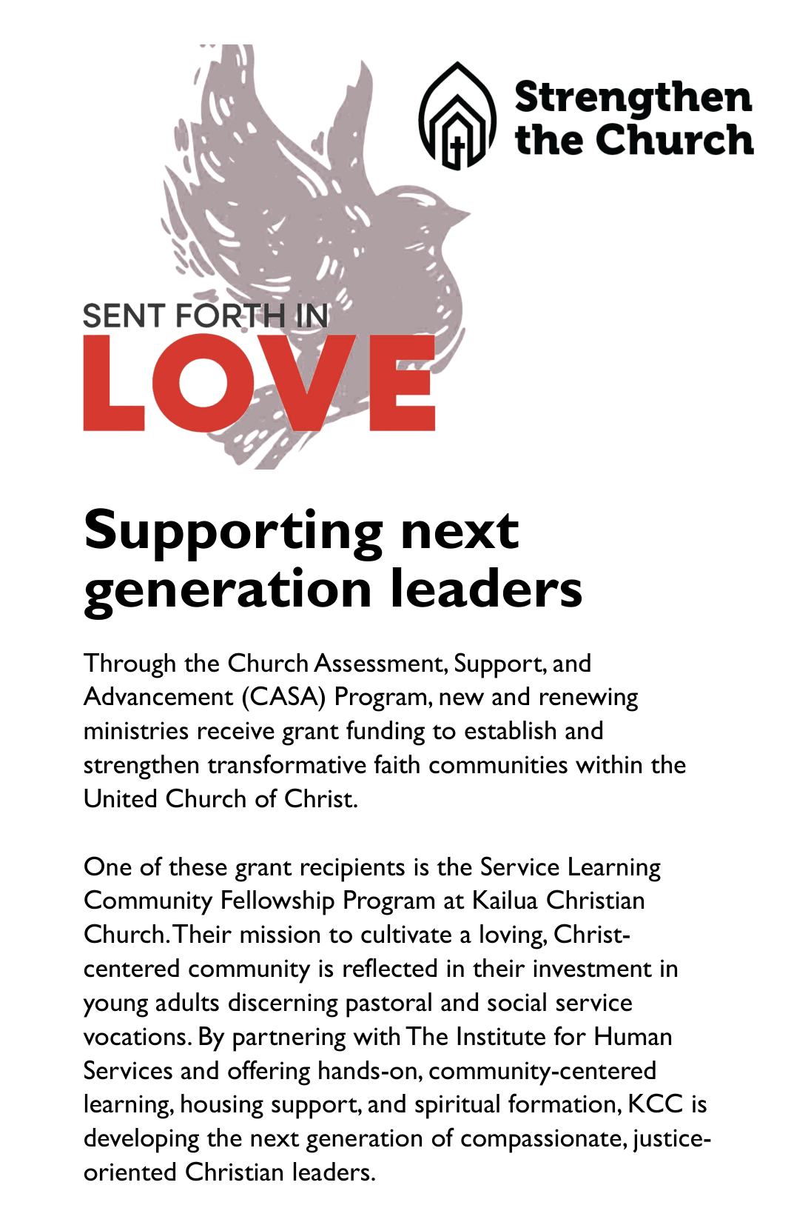

8
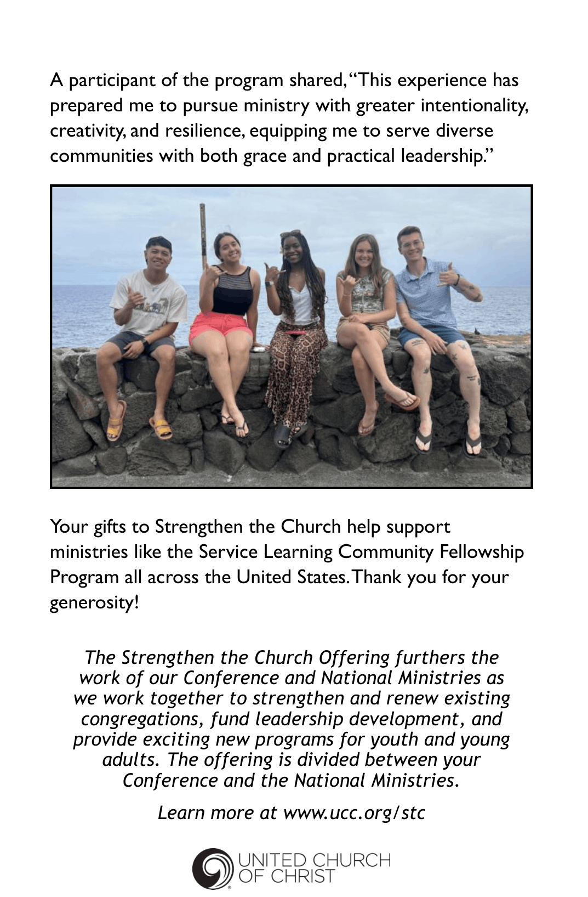

9
OUR FEDERATED VALUES
We believe in God
At the center of our faith is the surprising, unsettling, and deeply personal God found in the Bible, most profoundly revealed in the life, teachings, death, and resurrection of Jesus. At Federated, our primary interest is not merely talking about God but encountering the Mysterious Force at the heart of the universe. This is a God who comforts us where we need to be comforted and challenges us where we've become complacent. This is a God who will not be confined to dogmatic teachings, nor even to the Bible. We believe that we are invited to encounter this God everywhere: in nature, science, one another, and in other religious traditions as well.
We believe each person is on a unique spiritual journey
We value faith as a journey rather than a destination. We recognize that each person is at a different place on their journey, so we focus on “testimonies” of faith rather than “tests” of faith; stories of how we are being transformed, rather than dogmas we must affirm. Here, you are welcome to belong, question, explore, and lead whether you grew up in church and loved it, or you've had a painful relationship with Christianity; you are welcome whether you feel your faith is unshakeable or you're not sure if you believe in God at all. You are welcome to join a community of people “on the way”: encouraging and caring for one another, learning and growing together, and serving alongside each other as we build, in some small way, the world we believe God dreams of.
We believe in building authentic community across our differences
We are an “Open and Affirming” congregation, which is our way of saying that we value diversity. In a time of deep division, we believe it is paramount to gather people across lines of difference—race, class, culture, citizenship status, gender, sexuality, age, and ability—not merely to tolerate each other, but to build authentic relationships and true belonging. We believe the simple but courageous work of showing up in this way is one necessary element in healing our nation and world's deep divisions.
We believe in working for peace through solidarity & justice
At Federated, conversations about racism, sexism, immigration, transphobia, poverty, and a host of other issues are commonplace—from the pulpit and around the table. With Dr. King, we believe we are all “caught in an inescapable network of mutuality, tied in a single garment of destiny,” and that “none of us can be free until all are free.” These conversations connect us to each other and build trust as we commit to
accompanying each other—and our neighbors in the wider community—across our differences, and together work toward building a just and loving world for all.

“Welcoming Any, Loving All”

The Federated Church is affiliated with two national denominations:
the United Church of Christ & the Unitarian Universalist Association







Follow us on
Facebook & Instagram:
@FederatedChurchSycamore

www.fedsycamore.org

Church Office Phone: (815) 895-2706 || Email: Office@fedsycamore.org
Pastor Eric Cell: (815) 797-2250 || Email: RevEric@fedsycamore.org
Director of Children’s Church: Bill O’Hagan
Children’s Ministry Support Staff: Khat Hetland

Federated Church Preschool, Director: Bobbi Clough
Phone: (815) 764-9473 || Email: Preschool@fedsycamore.org
Address: 612 W. State Street, Sycamore, IL 60178

