Order of Worship | September 13, 2026, 10:00 am
All music is from the Black New Century Hymnal in your pew back, unless noted with (p. X).
* indicates moments in the service where you are invited to stand or rise in spirit
Please join in reading those parts printed in bold.
Prelude “Because He Lives” Wm. & Gloria Gaither/arr. B. Wolaver
Welcome & *Passing the Peace
We invite you to rise as you’re able, turn toward each other,
and welcome one another with a sign of God’s hospitality and peace.
Parents w/children 0-4 years old are invited to worship in the PrayGround at the front.
*Gathering Song “All Are Welcome” (p.3)
Sacrament of Baptism
Pouring of Water & Invitation
Covenant Promises of the Parents
Covenant Promises of the Godparent
Covenant Promises of the Congregation
Will you who witness and celebrate this sacrament promise your love, support, and care to this child who is about to be baptized?
We will, with the help of God. With this sacrament we welcome Rosalie Ann Meyers into the family of Christ’s Church, and invite her to share with us the joyful lifelong pursuit of discipleship. We promise to receive her as a beloved child of God, to nurture her in faith and hope, and to grow with her in the knowledge and love of Jesus, our Christ. Amen.
Prayer of Blessing
Sacrament of Baptism
See what love God has for us, that we should be called children of God.
God of Life, we thank you for Rosalie Ann; bless her and keep her, now and forever.
Introduction to the Family of Faith
Sung Response “For Everyone Born” vv. 1 & 5 (insert)
After singing, children 4-10 years-old will gather in the back with Ms. Sarah & Ms. Khat for Children’s Church. Parents are invited to pick up their child(ren) after the Postlude.
Prayers of the People
Silent Prayer & The Lord’s Prayer
Our Father/Mother/Creator who is in heaven, hallowed be your name.
Your kin(g)dom come, your will be done, on earth as it is in heaven. Give us this day our daily bread, and forgive us our debts, as we forgive our debtors. Lead us not into temptation, but deliver us from evil. For yours is the kin(g)dom, the power, and the glory forever. Amen.
Sung Response #472 “Precious Lord, Take My Hand”
Scripture Luke 7:31, 33-35; Acts 10:23-11:18 (excerpts)
Sermon “The Way of Radical Reconciliation”
Musical Meditation
Our Shared Life & Offering
Offering Opportunities
Offertory
*Doxology
Praise God from whom all blessings flow.
Praise God all creatures here below.
Praise God for all that Love has done.
Creator, Christ, and Spirit, One. Amen.
*Prayer of Dedication
*Sending Song “Sing a New World into Being” vv. 1-3 (p.4)
*Benediction
Postlude “Almighty” Wayne Watson/arr. B. Wolaver
We invite you to remain seated as the postlude plays. Afterward, parents may pick up their children in the chapel. Please join us afterward for Fall Fest lunch and activities!

WORSHIP NOTES
Serving us this morning:
Pastor: Rev. Eric J. Ogi | Ministers: All of us! | Music Director: Gary Mattin
Children’s Church Director: Bill O’Hagan | Children’s Ministry Support: Khat Hetland Liturgist: Sheldon Turner | Ushers: Ruth Olle, and Gip Seaver
Ushers for Sunday, September 20: Pam & Nate Kitterman and Allison Stahl
All music is used with permission: CCLI Copyright: #3234671; CCLI Streaming: #22467093
CONGREGATIONAL NOTES
Church Leadership for August 2026 – August 2027:
Moderator: Bill O’Hagan | Assoc. Moderator: Jane Whitaker | Past Moderator: Gip Seaver | Should you have any questions concerning the church, how to get involved, or who to contact about something, please reach out to one of them or Pastor Eric, and they will get you the information you need or connect you to someone who can.

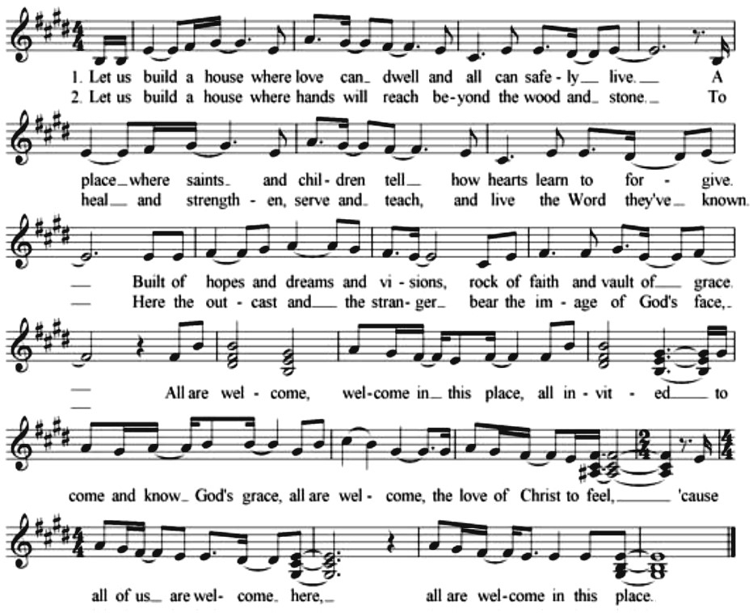
“All Are Welcome” by Marty Haugen & Mark Miller

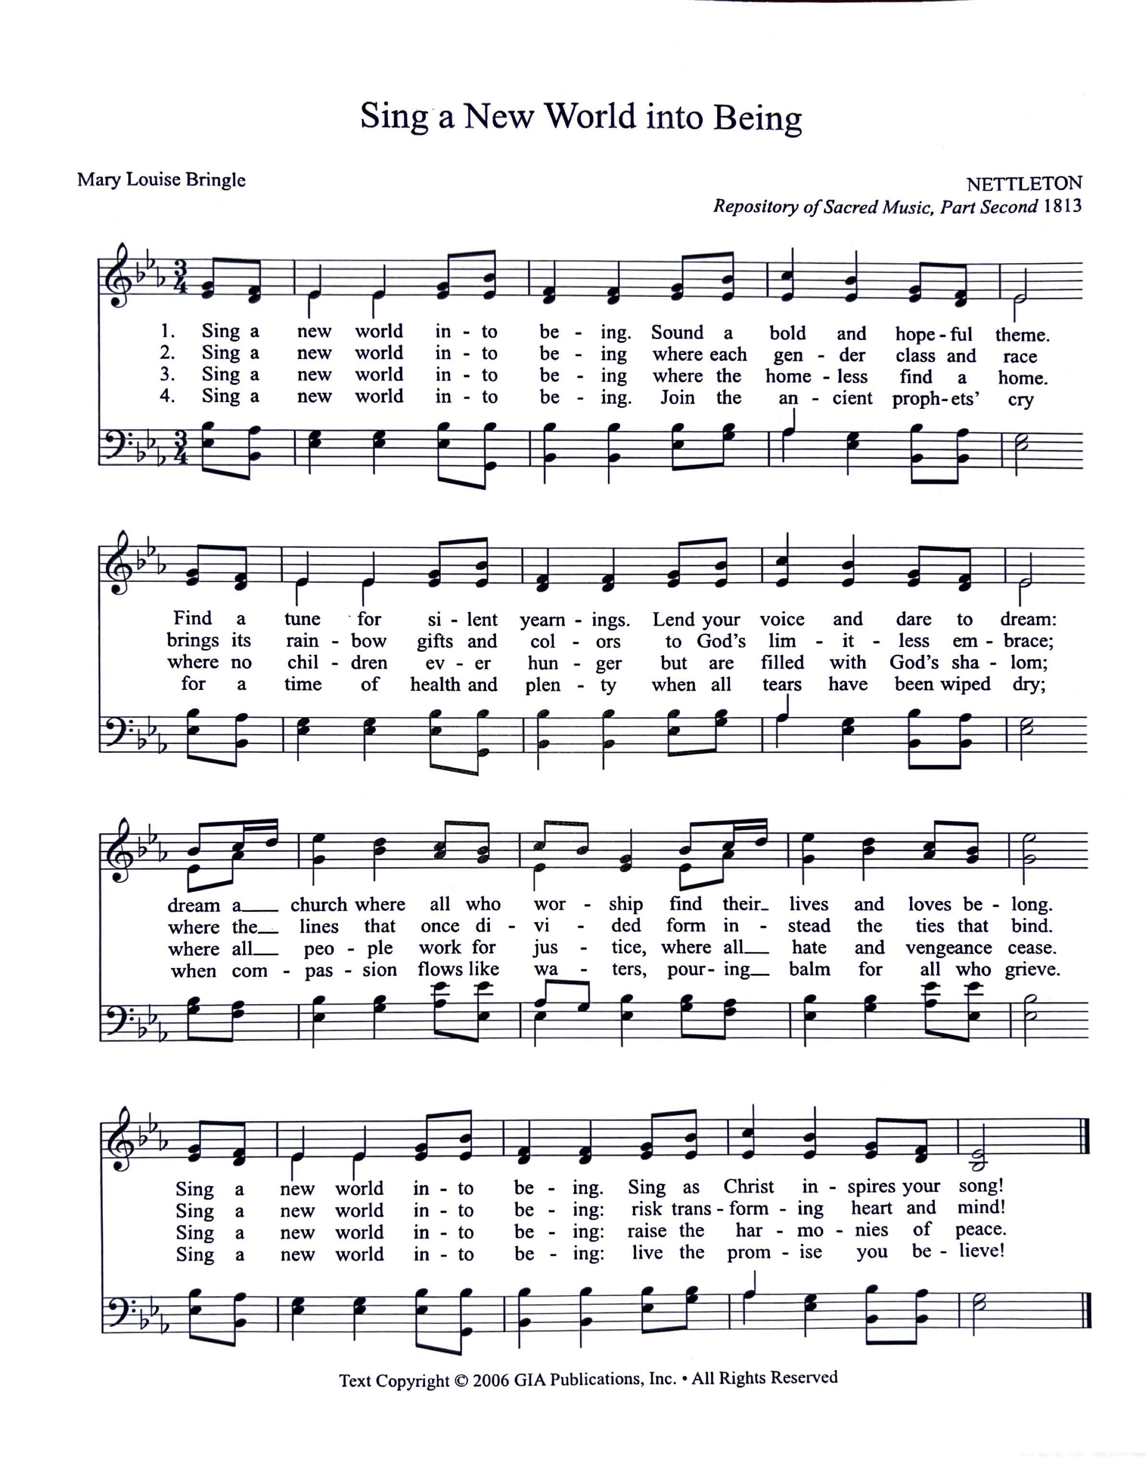
“Sing a New World into Being” by Mary Louise Bringle

